1. 
2. Sometimes, developers want to run the app outside of IDE.
3. One option is to use command line.   
   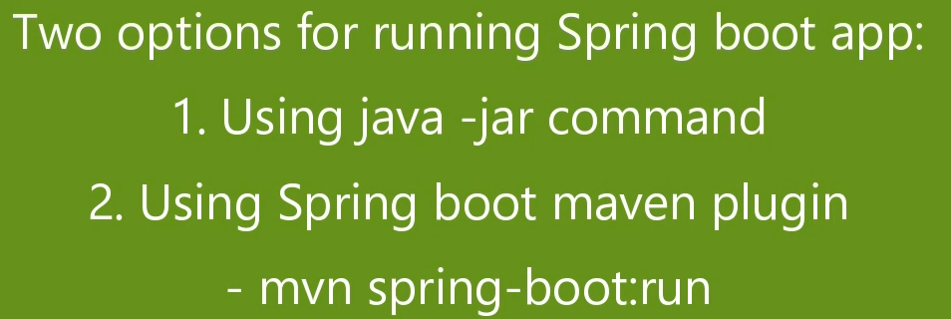
4. 
5.   
     
   